How to setup Tenda N4 PPPoE mode
Product line: Router Model number: N4
This article will guide you how to setup Tenda N4 PPPoE mode and the steps as below.
Note: If you have no idea about what is the internet connection type, the accounts (user name and password) please call your ISP for them.
Part 1: Connect the devices
Part 2: Configure your computer
Part 3: Setup the router
Part 4: Check whether you can access internet
- Connect the broadband line with the WAN port of N4, and then connect your computer with LAN port of N4 by a cable.
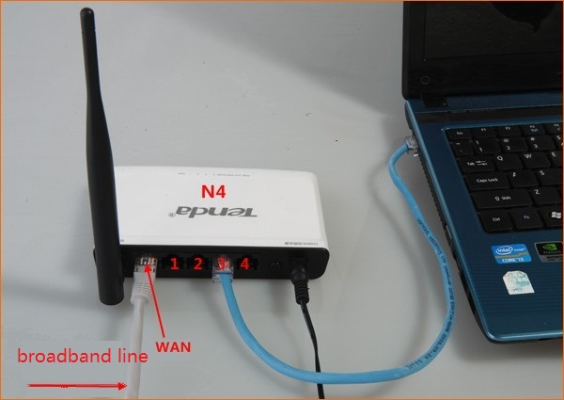
Note: After connection the SYS light should be blinking, the PWR and WLAN lights should be on or blinking.
1. Click on Network Connection Icon on the system bar, then click on Open Network and Sharing Center.
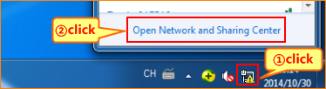
2. Click on Change adapter settings.
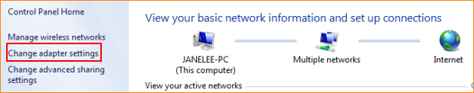
3. Right click on Local Area Connection, then choose the Properties option.
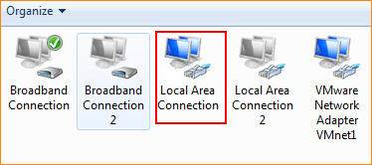
4. Double click on Internet Protocol Version 4(TCP/IPv4).
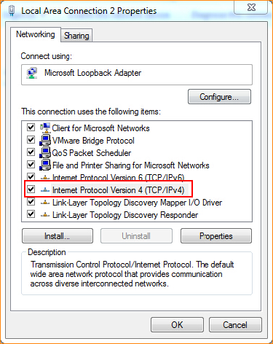
5. Choose Obtain an IP address automatically and Obtain DNS server address automatically and then click OK.
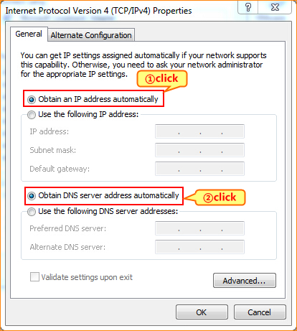
6 Also click on OK on the first Local Connection Properties window.
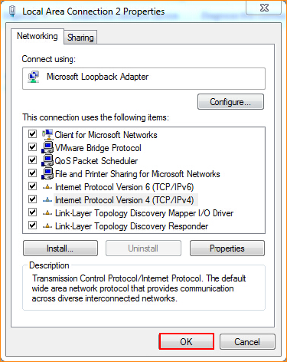
3.1 Setup the router in home page
3.1.1 Open a browser then type 192.168.0.1 in the Address bar, click on Enter.
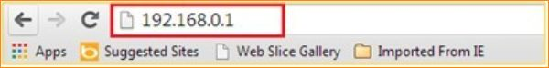
3.1.2 Choose the PPPoE option and then please type in user name and password (you can consult your ISP for it if you don’t know). Then set for the wireless security, click on OK to save the settings, then click on Advanced.
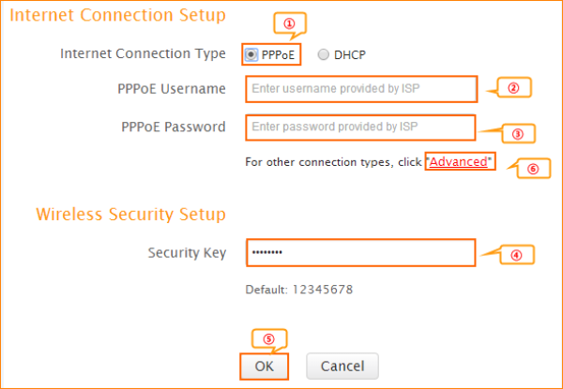
3.1.4 After setting, please click on Tools, and click on Reboot then hit on the Reboot The Router button to reboot the router for refreshing the device info.
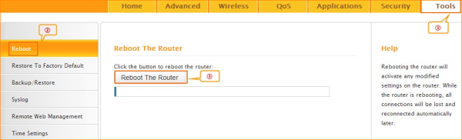
4.1 Click on Advanced to login the advanced setting page, then check the Status if the Connection Status shows Connected that means you can access internet, please check.
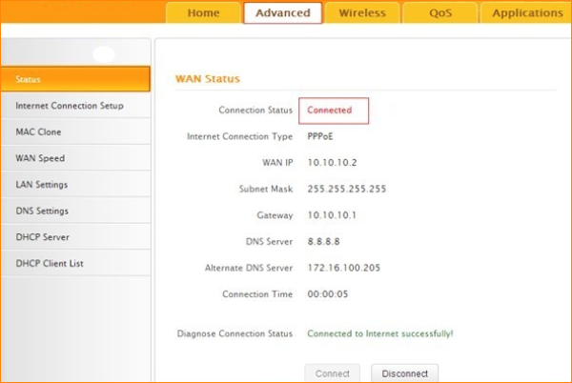
4.2 If you can’t, please click here and follow the steps below.
4.2.1 When the Connection Status shows Disconnected, it means that there are some problem with the WAN Connection. please check hardware connection.
4.2.2 When the Connection Status Show Connecting, please try the steps as below:
A: Please check if you put the correct username and password from your ISP
B: Click Advanced——MAC Clone——Clone MAC Address to clone your computer’s MAC address to the router’s WAN port, then click Ok to save the setting and click Reboot.
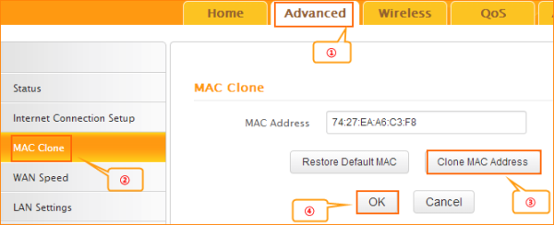
C: Click Advanced——LAN Settings——IP address, change it to 192.168.10.1, click Ok to save the setting and the router will reboot automatically.
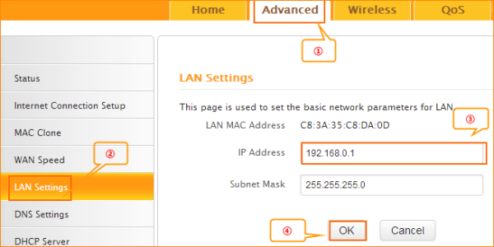
D: If the Connection Status is still Connecting, please reboot the modem and router together.

